IDB lab-2

1. 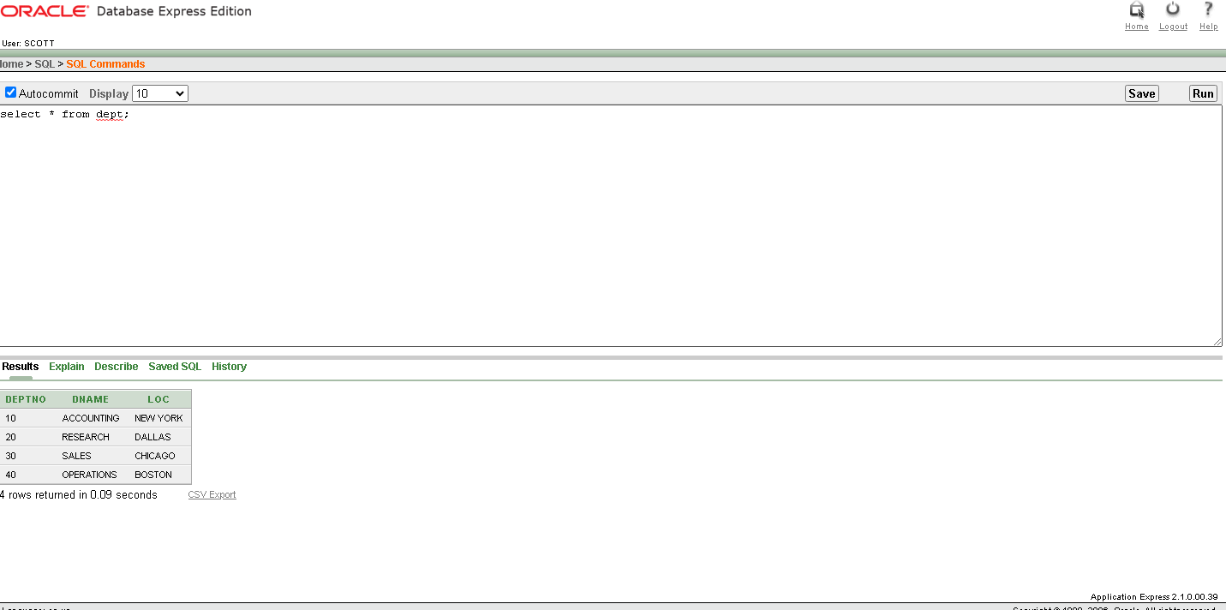Select \* from dept;
2. Select deptno, loc from dept;

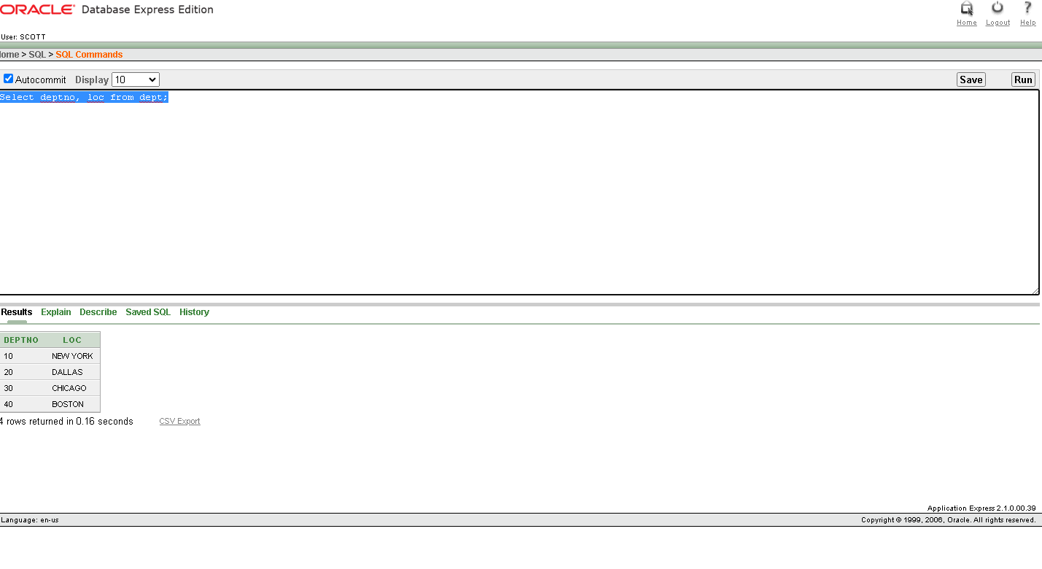

3.Select ename, sal, sal+300 from emp;

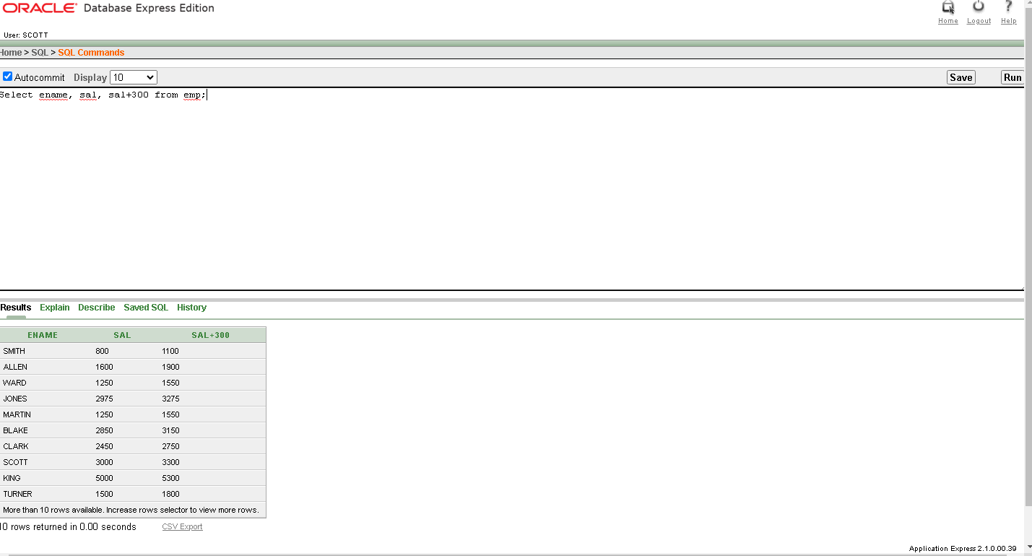

4.Select ename , sal, 12\*sal+100 from emp;

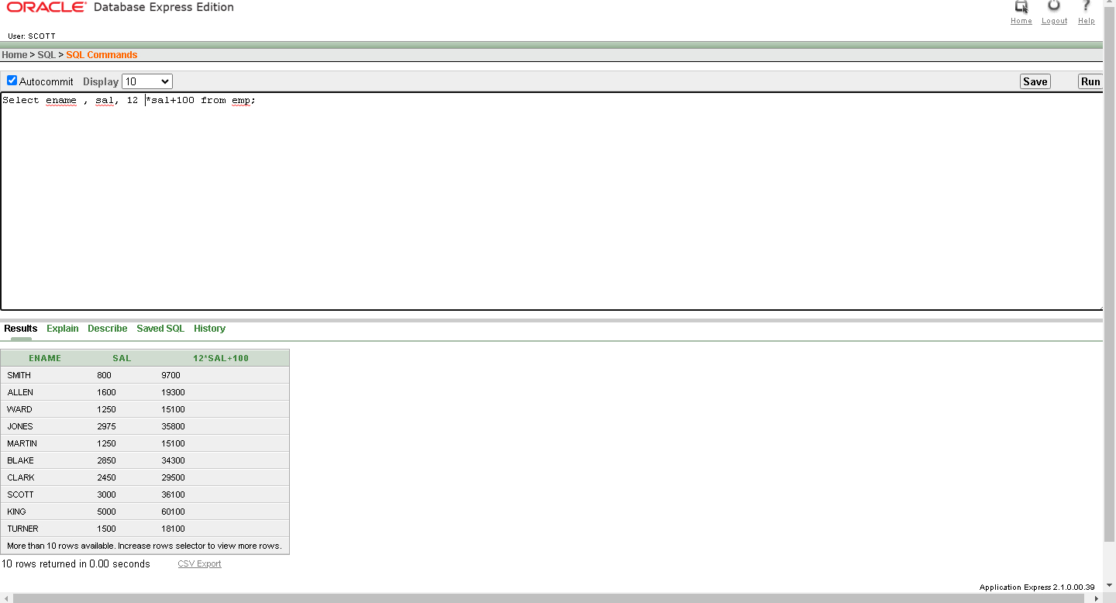

5. Select ename, sal, 12\*(sal+100) from emp;

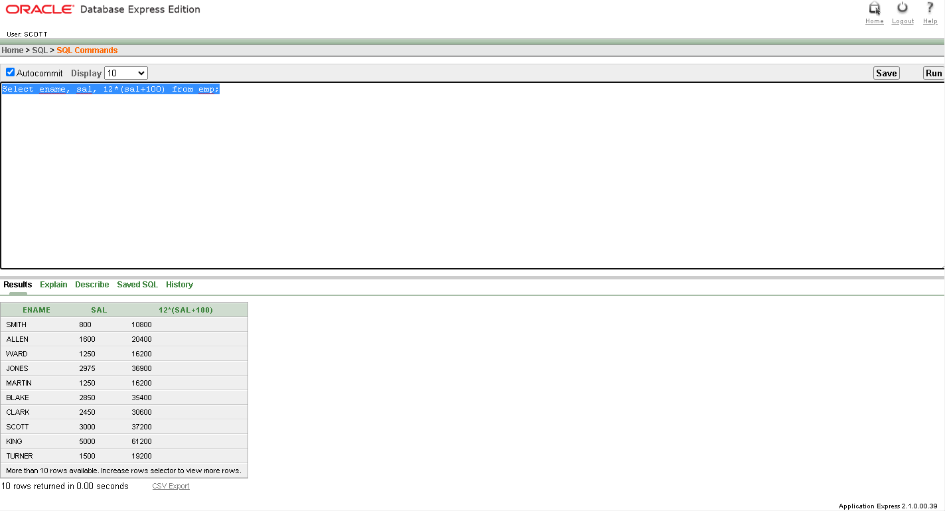

6. Select ename, job, comm from emp;

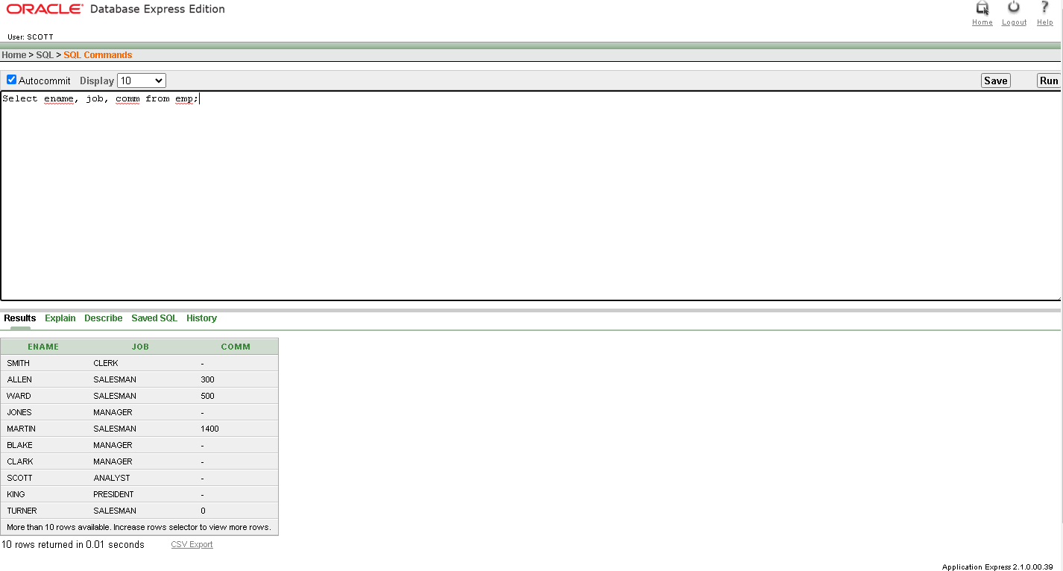

7. Select ename, 12 \* sal+comm from emp where ename = ‘KING’

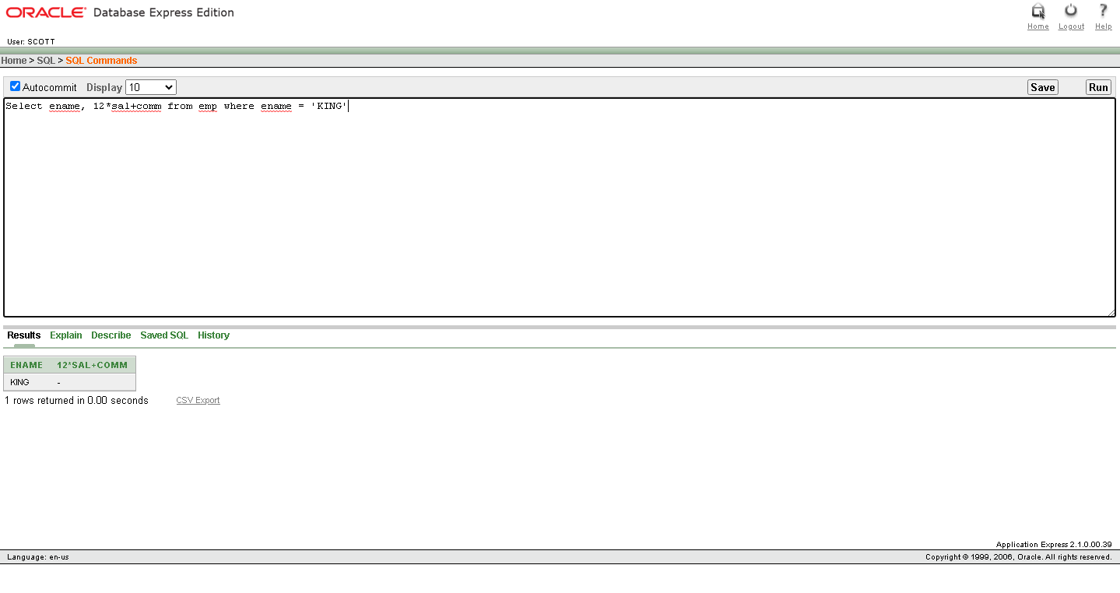

8.Select ename as name , sal salary from emp;

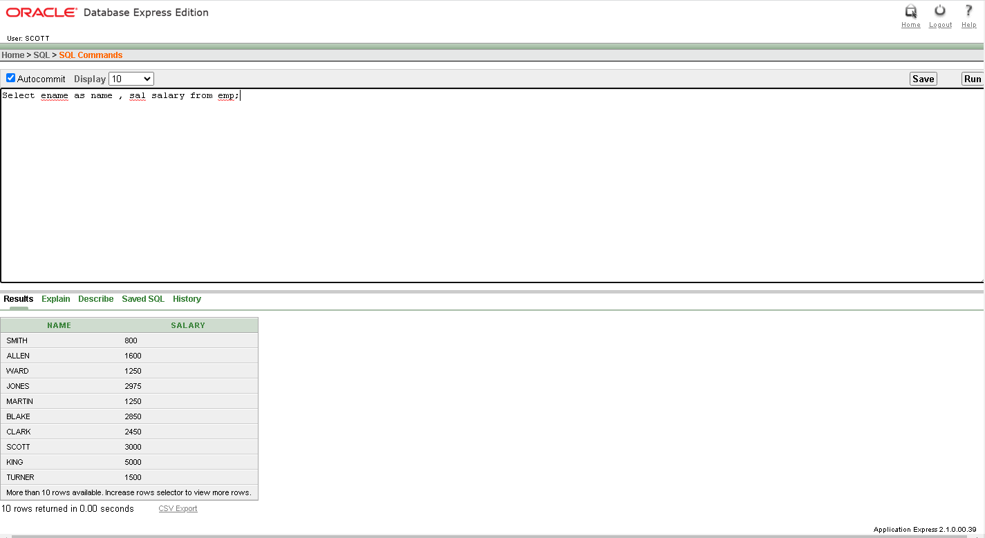

9. Select ename “Name” , sal\*12 “ Annual Salary” from emp;

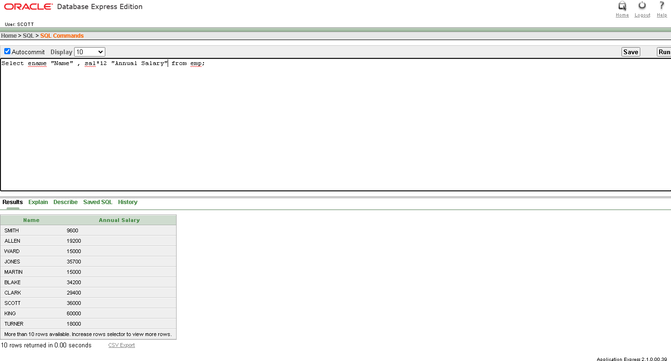

10. Select ename|| job as “ Employees” from emp;

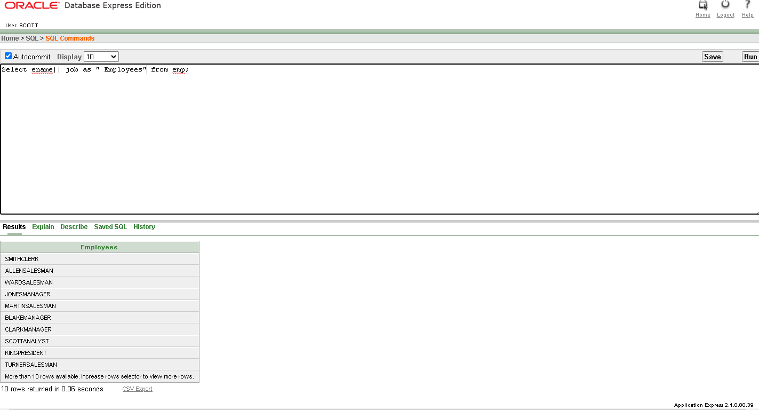

11. Select ename || ‘ ‘ || ‘ is a ‘ || job As “ Employee Details” from emp;

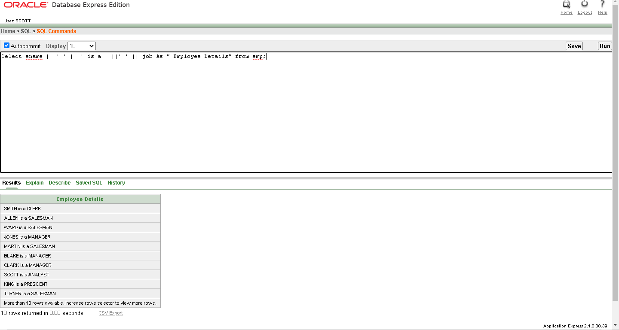

12. Select deptno from emp;

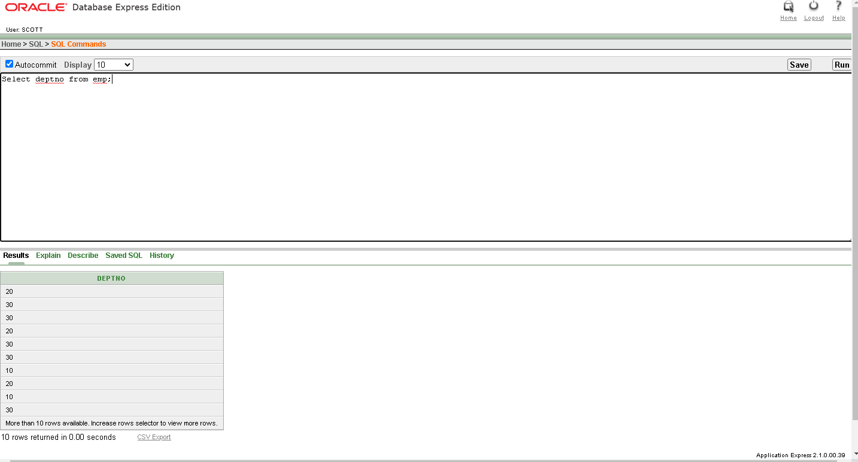

13. Select Distinct deptno from emp;

